**Teacher Candidate:** Bahara Baghkhanian **Date:** November 15, 2017

# Writing Process UCI LESSON PLANNER

**Part 1: Classroom Information**

**Grade:** Kindergarten **Content Area:** English Language Arts: Writing Process

**School:** Cypress Village Elementary School  **Mentor Teacher:** Carrie Pearson

**Group Size:** 31 **Lesson Length:** 30 minutes

**Student Context:**

|  |  |  |
| --- | --- | --- |
|  | Identified Student Needs | Accommodations During Instruction to Support Student Needs |
| Students with Special Needs (IEP and/or 504) | N/A | N/A |
| Students with Specific Language Needs (ELL) | There are 16 students that are classified as ELL, however only 2 of the children are at the emerging level of ELD proficiency. | Support students by modeling the task prior to having them engage in the learning activity. Use and frequently reference visual representations throughout the lesson. Pre-teach students key vocabulary words. Repeat instructions, remodel, and clarify as necessary. |
| Students with Other Learning Needs (Behavior, Struggling Reader, Struggling Math) | N/A | N/A (My Mentor Teacher stated that there are currently no students who she perceives to have specific behavioral/learning needs. As the year progresses, she will have a better understanding of which students require additional support or accommodations to enhance learning). |

**Part 1: Planning for the Lesson**

**A: Standards**

1. **Key Content Standard**:

CCSS.ELA-Literacy.SL.K.1A: Participate in collaborative conversations with diverse partners

about kindergarten topics and texts with peers and adults in small and larger groups. (A) Follow agreed-upon rules for discussions (e.g., listening to others and taking turns speaking about the topics and texts under discussion).

CCSS.ELA-Literacy.SL.K.3: Ask and answer questions in order to seek help, get information, or clarify something that is not understood.

CCSS.ELA-Literacy.SL.K.6: Speak audibly and express thoughts, feelings, and ideas clearly.

CCSS.ELA-Literacy.W.K.2: Use a combination of drawing, dictating, and writing to compose informative/explanatory texts in which they name what they are writing about and supply some information about the topic.

1-LS1-1A Structure and Function: All organisms have external parts that they use to perform daily functions.

1. **Related ELD Standard (must be included when using an ELA Standard)**:

Collaborative: Exchanging information and ideas with others through oral collaborative conversations on a range of social and academic topics (CCSS.ELA-Literacy.SL.K.1, CCSS.ELA-Literacy.SL.K.6, 1-LS1-1A Structure and Function)

Interpretive: Listening actively to spoken English in a range of social and academic contexts (CCSS.ELA-Literacy.SL.K.3)

Productive: Composing/writing literary and informational texts to present, describe, and explain ideas and information, using appropriate technology (CCSS.ELA-Literacy.W.K.2)

**B. Objectives**

1. **Learning Objective/Goal**: The students will (**DO** __) to (**LEARN** ___).

Students will draw images and write expository sentence(s) describing components of trees to demonstrate an understanding that organisms have external parts that they use to perform daily functions.

1. **Language Objective** (transfer this from "Incorporating Academic Language"):

The students will describe different components of trees using key vocabulary words including leaves, branches, trunk, and roots.

**C. Assessments:**

1. Informal assessment strategies you will use during class (What informal assessment strategies will you use, what specific evidence will you see and/or hear and how will you note it?)

|  |  |
| --- | --- |
| Assessment Strategy | Evidence of Student Learning |
| Brace Map | Children will contribute information related to components of a tree. As students identify each part of the tree, the teacher will draw it on the brace map and label it accordingly. In addition, students will be asked to orally share information with regard to the function of each part of a tree. The ability to properly determine every element of a tree and its corresponding function will provide me with information indicating the students’ level of understanding with regard to the topic. |
| Monitor Student Work | As students illustrate and write about components of trees, the teacher will have the opportunity to visually understand whether they have grasped the content of the lesson. If children are able to draw an image of a tree and produce information in a sentence to identify component parts and functions, evidence of student learning will be visible. |
| Listen and Take Note of Ideas Shared Amongst Carpet Buddies | After each individual part of a tree is drawn and labeled on the brace map, students will discuss what function that particular component serves to the survival of the tree with their carpet buddy (each child has an assigned partner seated next to them on the carpet). Walk around the room as they share ideas with their partners and take note of thoughts that are discussed. In particular, write down the names and contributions of students who share accurate ideas so they can be intentionally selected to provide input to the whole class. When listening to students speak with their partners, evidence of student learning will be demonstrated if correct descriptions of plant functions are shared. |

1. Written assessment you will use to determine, **for each** individual student, to what extent they have met your learning objectives. (What evidence will you collect?)

Students will write expository sentence(s) to describe components of trees or functions corresponding to parts of trees. They will additionally draw illustrations related to each written sentence.

**D. Lesson Resources/Materials (e.g., student handouts, manipulatives, PPTs, text pages, special supplies) Attach copies of any student handouts or worksheets:**

Butcher Paper for Brace Map

Markers (Black, Brown, and Green)

Individual Student Journals (31)

YouTube Video: “The Tree Song- Learn about Trees! Roots, Trunks, and Leaves!”

(<https://www.youtube.com/watch?v=D7dKRBZVLvI>)

**Part 2: Instructional Sequence - Engaging Students in the Learning Process**

**Writing Process** Briefly describe the strategies for each step of the writing process. Bold which step is included in this lesson plan.

**Prewriting – Students will contribute ideas aloud to the entire class, identifying each part of a tree. The parts will be drawn and labeled on the brace chart. After each individual component is identified, students will discuss what function that particular component serves to the survival of the tree with their carpet buddy. The description will be added to the brace chart.**

**After covering each part of the tree, guide students in a song and dance related to trees. The song will go to the tune of “Heads, Shoulders, Knees, and Toes,” but will instead include the lyrics “Leaves, Branches, Trunk and Roots.” Movements will correlate from the top down, with students touching their heads, shoulders, knees, and toes.**

**Have the children sit in their carpet squares and will provide them with example sentence frames to use for the writing piece of the lesson. First, write the sentence frame “Trees have ______” on the whiteboard. Model completing the sentence with one of the words on the brace map (ex: “Trees have roots”). Additionally model a second sentence frame based on the part of the tree that has been identified. Write the sentence frame “ They help trees ______” on the whiteboard. Complete the sentence with the word “roots.” The complete statement should appear as follows: “They help trees by moving water up them.”**

Prompt – Student Language – **“**Now that we have talked about trees, you are each going to write a sentence about at least one part of a tree. You will write, “Trees have ____” in your journals and will fill in the blank with a part of a tree that we went over during the lesson. Then, you will draw a picture of that part of the tree on the top section of your journal. If you finish and still have time, you will write, “They help trees _______” in your journal. You will complete the sentence by writing about how the part of the tree you identified in the first sentence and picture helps trees survive. Then, you will draw a picture of a tree on the top section of your journal and do your best to label as many parts as you can.”

Drafting – Students will write their sentence(s) and draw pictures in their individual November journals.

Sharing – Students will take turns reading their sentence(s) aloud to an elbow partner sitting next to them at the table.

Revising – Students will add new thoughts by incorporating additional sentences or clarifying existing ideas by adding more description.

Editing – Students will read through their sentences and check for proper capitalization and punctuation marks. In addition, students will read each word to ensure that all phoneme-grapheme relationships are accounted for.

Evaluating – Students will specifically be evaluated based on whether they have accurately written a sentence identifying a component of a tree. In addition, an image of a tree with labeled parts (at least one label) must be drawn in the journal. (These are the elements that must be seen within student journals. Although children are encouraged to write about how the part of the tree they identified contributes to the functioning and survival of the plant, they will not be marked down if they are unable to do so).

**Introduction (5 min.):** Describe how you will 1) make connections to prior knowledge, tap into their experiences and interests or use a “hook”, **AND** 2) let students know what the objective of the lesson is.

I will begin the lesson by playing the following video entitled “The Tree Song- Learn about Trees! Roots, Trunks, and Leaves!” (<https://www.youtube.com/watch?v=D7dKRBZVLvI>)

This is intended to activate students’ prior knowledge of trees related to two lessons taught the prior week. The first lesson involved reading the book “Trees,” by Delta Education, and the second had to do with composing a circle map about trees.

Then, tell the students that each of them will write a sentence(s) to identify at least one part of a tree, and will draw an image of a tree with labeled components in their journals.

## Body of the Lesson (20 minutes): Describe step-by-step what the teacher and the students will be doing during the lesson.

Place the blank piece of butcher paper on the board so it is visible to all students.

Ask students to silently think about different parts that make up a tree and provide a silent thumbs-up signal against their chests when they have come up with an idea that they would like to share.

Select students demonstrating a silent thumbs-up to share their ideas aloud with the class.

As each thought is provided, draw the representative component of the tree on the left side of the butcher paper. In addition, draw a line in the brace map to the right of the image, label it, and illustrate a miniature version of the particular part of the tree next to the word (Appendix A).

For example, if a child says “trunk” aloud, draw a big trunk on the left side of the butcher paper, draw a line on the right side of the brace map, label it with the word “trunk,” and illustrate a miniature image of a tree trunk beside the word.

ELL Support: After drawing and labeling each component, explicitly repeat the vocabulary word and point to the large image in order to solidify the connection for the children. In addition, ask students to repeat the vocabulary word using the sentence frame “Trees have _____.”

*** Repeat this process until each component of the tree has been identified, drawn, and labeled. (Parts include: roots, trunk, branches, and leaves)

After each part of the tree is drawn and labeled, ask the children to take turns sharing ideas of what function that particular component serves to the survival of the tree with their carpet buddy.

Provide the students with the sentence frame “They help trees ______” to use when speaking with their carpet buddies.

ELL Support: Intentionally pair native English speakers with ELL students to provide them with models of how to properly use the sentence frame and construct a complete thought related to the prompt.

As students discuss ideas with their carpet buddies, circulate the room, listen, and take note of thoughts that are shared.

Ask students to raise their hands if they would like to present their ideas to the class. Intentionally select students whose ideas were noted so that vital information can be shared aloud for everyone to hear.

Condense the thoughts into a concise statement about the particular part of the tree and write it in parentheses next to the label on the brace map.

*** Repeat this until each component of the tree has been discussed (Parts include: roots, trunk, branches, and leaves)

Have the children stand up and tell them that they will be learning a song and dance to remember the names of the parts of trees and their location. Ask students to first watch the demonstration and then follow along.

Model the vocal expressions and physical movements related to the activity. Place hands on the head and say “leaves.” Follow this by touching shoulders and say, “branches.” Then, place hands on the knees and say “trunk.” Finally, bend down, touch toes, and say “roots.”

Have the children follow along in a guided manner two times and then have them perform independently four times.

ELL Support: As the children independently practice the song and movements, go to the board and point to each part of the tree as it is mentioned in the activity.

**Closure (5 minutes):** Describe how you will prompt the students to summarize the lesson and restate the learning objective.

Have students sit on their carpet squares and ask them to share at least one part of a tree they will write about in their journal with their carpet buddies.

Ask each pair to share the idea that their partner mentioned in order to ensure that they were actively listening while their carpet buddy spoke. This also solidifies an additional component of a tree in each child’s mind in addition to their own.

**Part 3: Incorporating Academic Language**

(to be completed after you have planned the content part of your lesson plan)

1. Describe the rich learning task(s) related to the content learning objective.

The rich task in this lesson consists of composing the tree brace map guided by student input. The process of drawing out, labeling, and identifying functions of components of trees solidifies student understanding of the material. In addition, key information is identified, which subsequently supports children as they write their thoughts in their November journals. This task is rich in that it allows for students of all skill levels to learn from the lesson. As students express their thoughts aloud, components of trees are identified in conjunction with their functions. The educator has students share their own ideas with minimal scaffolding, which subsequently encourages the children to think deeply about key parts of trees and their functions.

1. **Language Function:** How will students be communicating in relation to the content in the learning task(s)? Identify the specific **function** (purpose or genre) you want to systematically address in your lesson plan that will scaffold students to stronger disciplinary discourse. The language function will always be a verb. Some examples are: describe, identify, explain, justify, analyze, construct, compare, or argue.

**Describe**

1. **Language Demands**: Looking at the specific function (purpose or genre) your students will be using, what are the language demands that you will systematically address in this lesson?

**Vocabulary:**

Key to this lesson: Tree, leaves, branches, trunk, roots

**Syntax**[1]: Sentence frames are used to assist students in structuring statements with regard to components of trees and their functions. While the following sentence frames will be provided for students to use and reference, they will be permitted to express their thoughts without the utilizing exact frame.

“Trees have ____.” “They help trees _____.”

**Discourse**[2]: The following oral sentence frames will guide discussion amongst carpet buddies as well as the entire class: “Trees have ____.” “They help trees ______.”

1. **Language Objective:** What is/are the **language objective(s)** for your lesson?

The students will describe different components of trees using key vocabulary words including leaves, branches, trunk, and roots.

1. What does your language objective sound like/look like for different levels of language learners? Ask yourself, “What would the students say/write when using the language function.” Remember to consider the language demands while creating sample language that the students might use.

|  |  |  |
| --- | --- | --- |
| **Emerging** | **Expanding** | **Bridging** |
| Children will produce beginning sounds of vocabulary words when completing the written sentence frame “Trees have ____.”  For example, the child might write, “Trees have r.” This would indicate an understanding of the beginning letter sound in the word “roots.” | Children will produce beginning and ending sounds of vocabulary words when completing the written sentence frame “Trees have ____.”  For example, a child might write, “Trees have rs.” This would indicate an understanding of the beginning and ending letter sounds in the word “roots.” | “Trees have _____.” Children at the bridging level will be able to use this sentence frame as well as the images and words on the board to properly complete the thought orally as well as in a written form.  In addition, they will be able to complete the sentence frame “They help trees _____” orally as well as in a written form. |

1. **Language Support:** What **instructional strategies** will you use during your lesson to teach the specific language skill and provide support and opportunities for guided and independent practice?

|  |  |  |
| --- | --- | --- |
| **Instruction** | **Guided Practice** | **Independent Practice** |
| Repetition of key vocabulary words.  Use of visual drawings to represent key vocabulary terms.  Connecting terms with visual representations on the brace map. | Modeling written ideas with the use of sentence frames.  Having children orally practice expressing their ideas to a carpet buddy with the provided sentence frame.  Modeling and guiding children in the “Leaves, Branches, Trunk, and Roots” song. | Students are provided with the sentence frames “Trees have _____” and “They help trees _____” to support them as they write their thoughts. |

1. Be sure to incorporate your ideas in #6 above into your actual lesson plan!

Assessment Notes:

* Be sure to incorporate assessment items of your targeted academic language into your assessments.

* Be sure to review any assessments you are going to use, and consider what modifications you may need to make for your language learners.

Appendix A

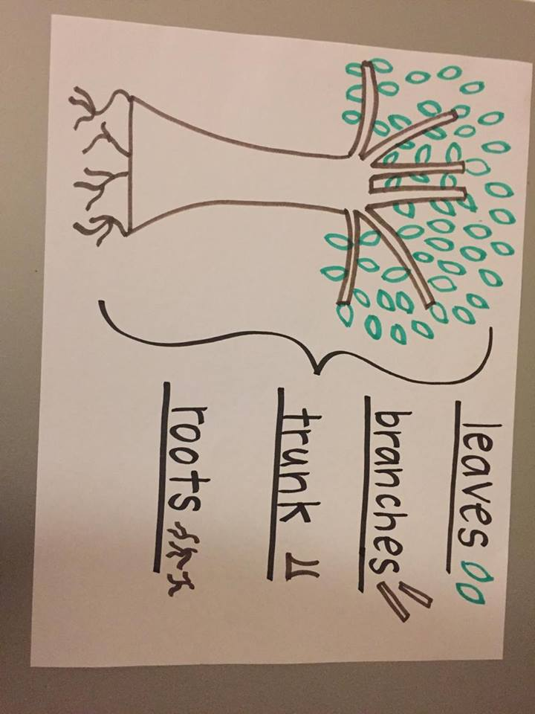

Appendix B

Lesson Rubric

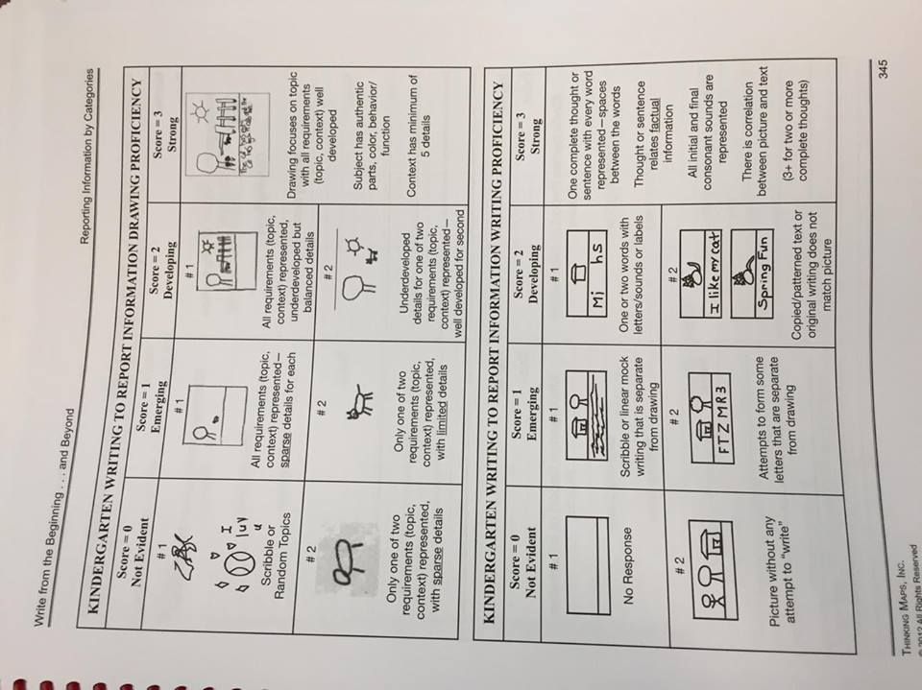

1. Use of a variety of sentence types to clarify a message, condense information, and combine ideas, phrases, and clauses.
2. Discourse includes the structures of written and oral language, as well as how member of the discipline talk, write, and participate in knowledge construction.